**LEARNING GITBASH**

**List Command** - Is

**Change Directory** - cd

**Clear Page** - clear

**Exit** - exit

**Make Directory** - mkdir

**Remove Directory** - rmdir

**Create File** - Touch "file name" .extension

**Remove File** - rm "file name" extension

**Edit File** - nano "file name" . extension

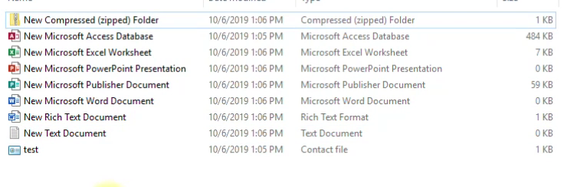

EXTENSIONS – zip, accdb, xlsx, pptx, pub, docx, rtf, txt, pdf, contact, etc.

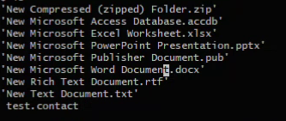

Extention of your choice.

FOR CREATING FILE YOU NEED TO TYPE THIS – touch (name).(extention)

**Creating React+Vite App**

npm create vite@latest *to create react app

project name:todolist

cd todolist *to go to the file

npm install *install packages

npm install axios react-icons *install more packages

npm run dev *to run the server